**Pizza Sales SQL Queries**

1. **KPI’S**

**1.Total Revenue:**

**Query: Select SUM(total_price) AS Total_Revenue from pizza_sales;**



**2.Average order value:**

**Query:** **SELECT SUM(total_price)/COUNT(DISTINCT order_id) AS average_order_value FROM pizza_sales;**



**3.Total Pizza Sold:**

**Query:** **Select SUM(quantity) AS Total_Pizza_Sold from pizza_sales;**



**4.Total Orders:**

**Query: select Count(Distinct order_id) AS Total_Orders from pizza_sales;**



**5.Average Pizzas Per Order:**

**Query:** **Select SUM(quantity)/Count(Distinct order_id) AS Avg_Pizza_Per_order from pizza_sales;**



**Problem Statements**

**1.Pizza Sold per Hour:**

**Query: select Hour(order_time) as Hour ,Sum(quantity) as Total_Pizza_Sold from pizza_sales**

**group by Hour(order_time)**

**order by Hour(order_time);**

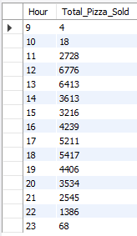

**2.Pizza Sold per Week:**

**Query:** SELECT WEEK(order_time) AS Week, YEAR(order_time) AS Year,

count(DISTINCT order_id) AS Total_Orders

FROM pizza_sales

GROUP BY WEEK(order_time), YEAR( order_time)

ORDER BY YEAR(order_time), WEEK(order_time);

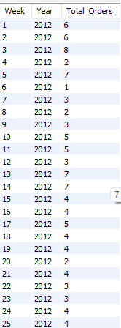

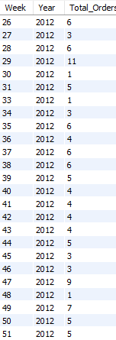

**3.Percentage of Sales by Pizza category:**

**select pizza_category,sum(total_price)*100/(select sum(total_price) from pizza_sales)as Percentage_0f_Total_Sales from pizza_sales**

**Group By pizza_category;**

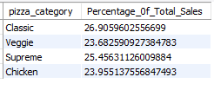

**Or,**

**SELECT pizza_size, pizza_category,**

**ROUND(SUM(total_price) * 100 / (SELECT SUM(total_price) FROM pizza_sales), 2) AS Percentage_of_Total_Sales FROM pizza_sales**

**GROUP BY pizza_size, pizza_category**

**order BY Pizza_size;**

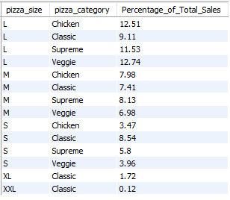

**4.Top 5 selling Pizza by Revenue:**

Query: Select pizza_name, Sum(Total_price) as Total_Revenue from pizza_sales

Group by pizza_name

order By Total_revenue desc LIMIT 5;

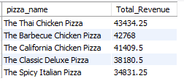

**5.Bottom 5 selling Pizza by Revenue:**

Query: Select pizza_name, Sum(Total_price) as Total_Revenue from pizza_sales

Group by pizza_name

order By Total_revenue LIMIT 5;

